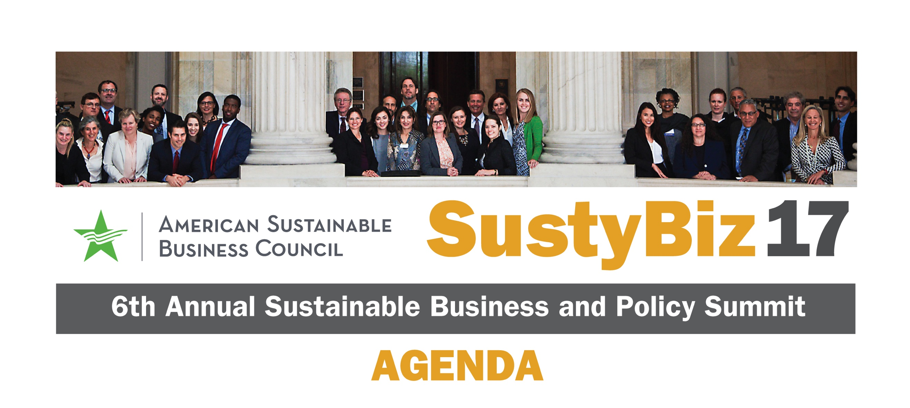

Sunday, October 22

6:00 pm – 8:30 pm Opening Reception at ASBC Office

*1001 G Street NW,  
 Washington, DC 20001*

Monday, October 23 *Washington Marriott at Metro Center, 775 12th Street NW Washington DC 20005*

7:30 am – 9:00 am Registration and Breakfast

*(Downstairs Lobby)*

7:45 am – 8:45 am Issue Working Groups *(Salon E)*

• Safer Chemicals

• Healthcare Reform

• Investing in Women Entrepreneurs

• Worker Ownership

• Tax Reform

• Clean Energy/Climate

9:00 am – 9:15 am Building the Sustainable Business   
 Movement: Lessons from the   
 Women’s March

9:15 am – 10:15 am Strategic Reforms for Strengthening Our Democracy and Making Government Work Better

**Bill Shireman**, Executive Director, Future 500

**Sarah Bonk**, Co-Founder,Disrupt DC

**John Pudner**,Executive Director,   
Take Back our Republic

**Wendy Weiser**,Director,   
Democracy Program,   
Brennan Center for Social Justice

**Richard Eidlin**,VP of Policy & Campaigns, ASBC

10:15 am – 10:45 am   Networking Break – Snacks/Beverages

1 on 1 Mentor Sessions with   
Key Business Leaders

Monday, October 23 (cont.)

10:45 am – 11:45 am Opportunities at the Federal Level   
to Further Sustainable Business Policy

Uri Berliner, Senior Business Editor, NPR

Caren Street, Policy Director,  
Congressional Black Caucus

Sarah Chamberlain, President and CEO, Republican Main Street Partnership

U.S. Representative Donald McEachin

11:45 am – 12:00 pm Break

12:00 pm – 1:30 pm Luncheon – Annual SUSTY Awards

SUSTY Awards Given to ASBC Members

Holly Sklar, Business for a Fair Minimum Wage

Jerry Taylor, Niskanen Center

Sandra Marquardt, Naturepedic

1:30 pm – 2:30 pm Role of Business in Creating Policy Change at the State Level

Dan Wolf, CEO & Founder, Cape Air

State Senator Cindy Friedman, Massachusetts

State Delegate David Fraser-Hidalgo, Maryland

Mike Mielke, SVP Energy & Environment, Silicon Valley Leadership Group

Dan Carol, Senior Advisor on Infrastructure and Energy,   
Office of Governor Jerry Brown

2:30 pm – 3:00 pm Networking Break – Snacks/Beverages

1 on 1 Mentor Sessions with   
Key Business Leaders

Monday, October 23 (cont.)

3:00 pm – 4:15 pm The New Business Activism   
at the Local Level

Mayor Mark Stodola, Little Rock, Arkansas

Marc J. Lane, Esquire, Marc J. Lane, P.C.

Anita Cozart, Senior Director, Policy Link

Chip Comins, President, AREI

4:00 pm – 5:15 pm A Deeper Dive: Building Your Skills

• Effective Advocacy Work:   
 How to Lobby Congress, State Capitol   
 & City Hall *(Salon A)*

Julia Watts, Deputy Policy Director, ASBC

Steve Masters, Esquire, Just Laws

• Crafting an Impactful Communications   
& Media Strategy *(Salon B)*

Bob Keener, Deputy Director   
Public Relations, ASBC

Andy Medici, Staff Reporter,   
*Washington Business Journal*

Marianne LeVine, Reporter, *Politico*

• Post Paris: Business Strategies   
 to Fight Climate Change *(Salon C)*

Nadine Gudz, Director of Sustainability   
& Strategy, Interface

Davida Heller, VP Sustainabiity, CitiGroup

Chris Blackburn, Policy Director, ASBC

Monday, October 23 (cont.)

• Enhancing Your Company’s/   
 Organization’s Policy Engagement Strategy   
 *(Salon D)*

Josef Lukan, Senior Manager, Global Policy and Advocacy, Levi Strauss & Co.

Sara Harper, Founder, Noble Growth Network

Richard Eidlin, VP of Policy & Campaigns, ASBC

6:30 pm – 8:30 pm Reception – Annual SUSTY Awards

SUSTY Awards Given to Policymakers

**U.S. Senator** **Angus King**

**U.S. Senator** **Sheldon Whitehouse**

**U.S. Representative** **Elijah Cummings**

Tuesday, October 24 *Hall of States, 444 North Capitol Street NW, Washington, DC 20001*

9:00 am – 10:00 am Breakfast on Capitol Hill  
Presentation by U.S. Senator Bernie Sanders

*Space is limited. However, confirmed participants for the Advocacy Day are guaranteed access.*

10:30 am – 5:00 pm Capitol Hill Meetings

U.S. Senators and Representatives

2:30 pm – 3:30 pm Briefing – The High Road Workplace: Route to a Sustainable Economy  
*Russell Senate Office Building, Room 485*

5:00 pm – 6:00 pm Closing Reception  
*U.S. Capitol Visitor Center, Room HVC 200*

